# XIV Support and PMR Tracking

## Needed Access

Everybody should already have:

1. access to the GSA drive
2. access to our group mailbox: SCE Plus Storage 24x7
3. installed XIV GUI on the laptop
4. extracted and configured XIV scripts for Linux

In addition to above mentioned, the following is needed for the PMR tracking:

1. access to XIV service center and configure it

<https://servicecenter.xiv.ibm.com/>

2. access to RETAIN Reader

<https://w3-03.ibm.com/systems/techlink/rr/pmr>

3. access to Service Requests and PMRs – (HW & SW)

<https://www-947.ibm.com/support/servicerequest/Home.action>

It takes a long time to get registered for all customer numbers. For some customer numbers it could take for months. At the beginning most of the work could be done without it, but the registration process should be started.

## XIV Service Center and Emails

Click on the below link and follow instructions to request the access

<https://servicecenter.xiv.ibm.com/>

Most commonly you will be doing the following from the XIV Service Center:

* View events
* View heartbeats
* View PMRs

You can also use other offered views.

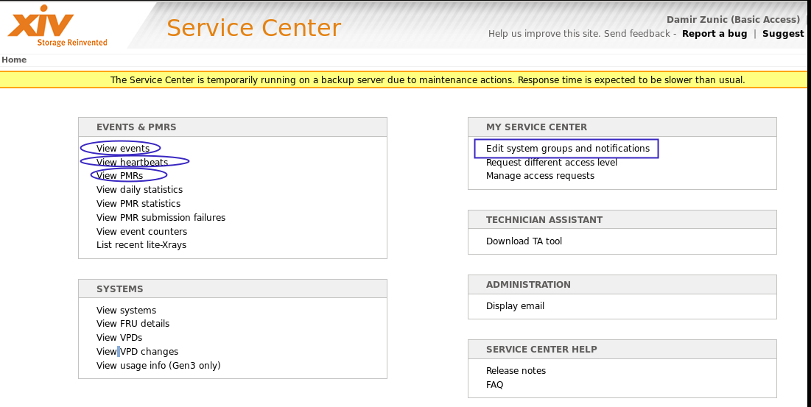

XIV Service Center first has to be configured by editing system groups. Create the group for every site using XIV serial numbers, like it is shown below.

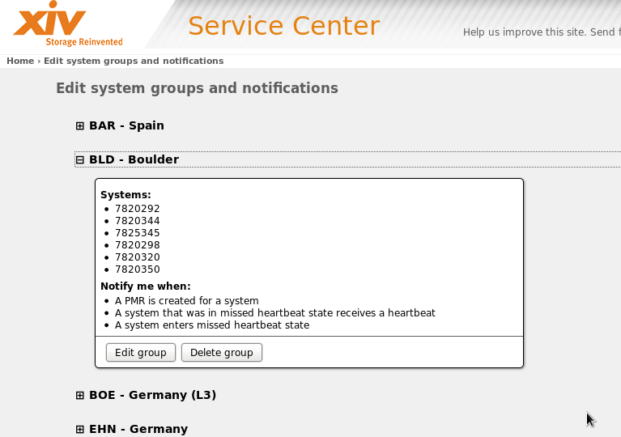

View events will be used more frequently:

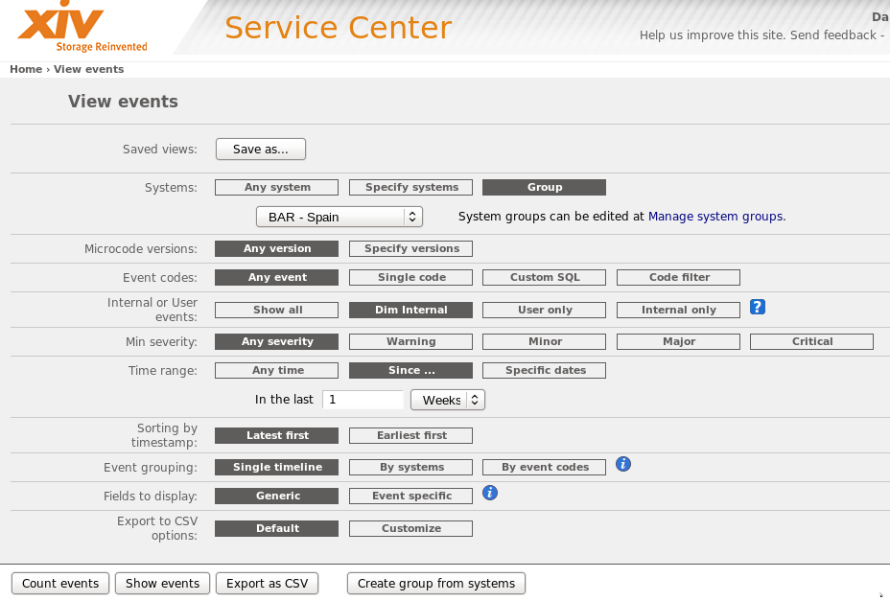

In addition to the events seen in the XIV Events log (User events), XIV Service Center displays internal events as well.

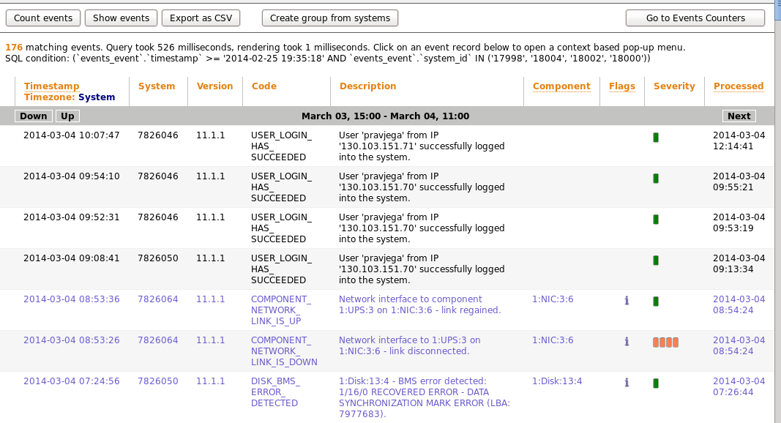

As it was shown above, XIV Service Center can send different notifications. In our example for PMR creation and heartbeats. You can use rules in Notes to automatically place those notifications in separate folders.

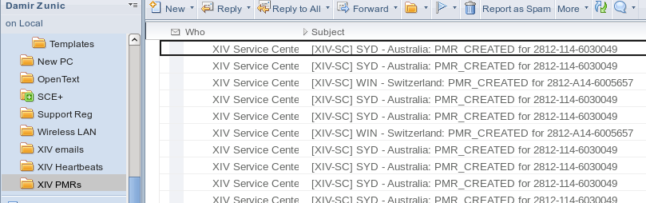

To make everything easier, I configured my Notes to copy those emails to our group mailbox. See below.

## Group Mailbox

All XIVs are configured to email events with severity Warning and higher to our group mailbox.

Events for each site are moved to their own folder under the folder XIV\Events. Expiration of those emails is set to 2 months.

We expect RTP Operations, XIV support and CEs to use our group mailbox ([scepstor@us.ibm.com](mailto:scepstor@us.ibm.com)) to contact us. So we should also use it for all communication with them. This way everybody can track resolution of PMRs.

As I mentioned above, I configured my Notes to email XIV Service Center notification emails to our group mailbox. They are forwarded directly to the folders XIV\PMRs and XIV\Heartbeats.

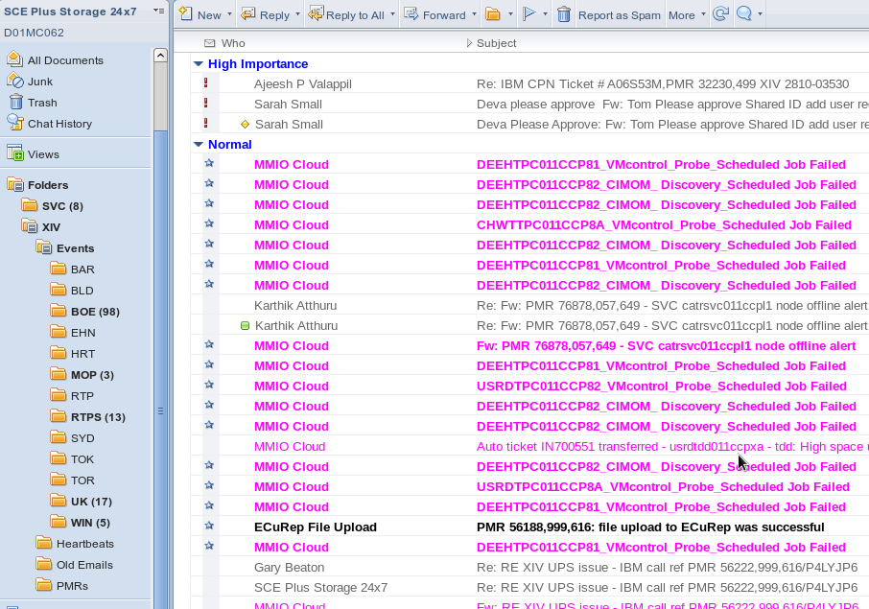

## RETAIN Reader

Click the following link to access the RETAIN Reader:

<https://w3-03.ibm.com/systems/techlink/rr/pmr>

Use the RETAIN Reader to read PMRs and see their development during time. For most of PMRs updates from support and CEs could be seen there. In some cases support will transfer the issue to RCMS and there will be no updates in PMR.

PMRs should be checked regularly and if there is no activity for some time support should be contacted. When and how to contact the support varies from site to site and depends from case to case.

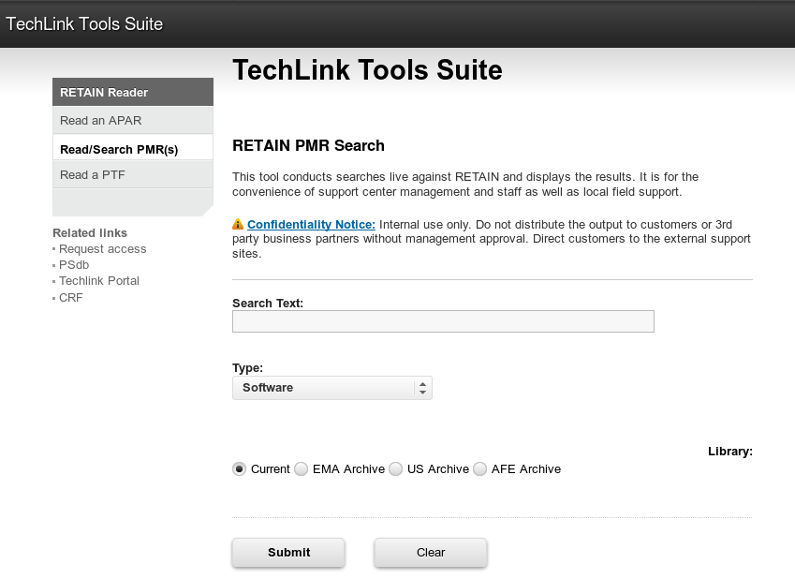

## ISM Incidents

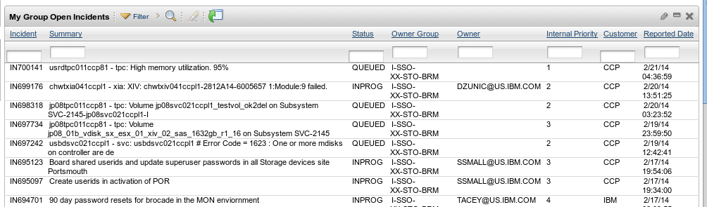

Accept the incident opened by ITNM or RTP Operations and close it when it is fixed.

## XIV Current Issues

Check the following document if the PMR and/or any issue is already listed there. If they are not listed let me know.

<https://pokgsa.ibm.com/projects/s/sce-plus/XIV/XIV_HW_Fix/XIV_Current_Issues.xls>

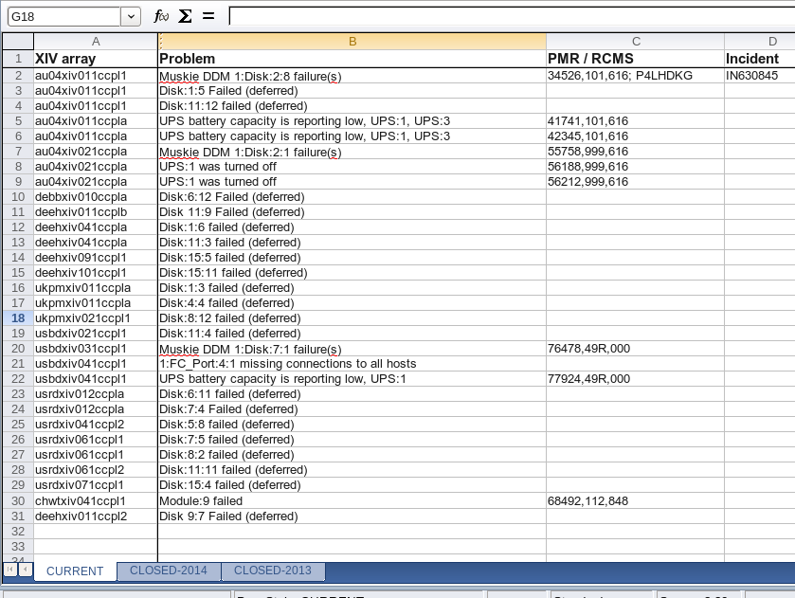

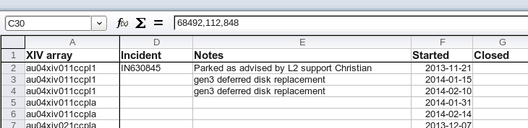

## HC (Health Check) Scripts – Replaced with SATHC

The new HC script is now a part of the XIV scripts environment that is described in the following document:

[https://pokgsa.ibm.com/projects/s/sce-plus/XIV/Scripts/XIV%20Scripts%20for%20Linux.odt](https://pokgsa.ibm.com/projects/s/sce-plus/XIV/Scripts/XIV Scripts for Linux.odt)

[dzunic@oc6028821555 XIVscripts]$ pwd

**/home/dzunic/XIV/XIVscripts**

[dzunic@oc6028821555 XIVscripts]$ ll

total 56

-rwxrw-r--. 1 dzunic dzunic 7217 Feb 21 10:53 **HealthCheck.ksh**

drwxrwxr-x. 2 dzunic dzunic 4096 Feb 6 15:47 host_lists

drwxrwxr-x. 2 dzunic dzunic 4096 Feb 12 15:47 local_out

-rwxrw-r--. 1 dzunic dzunic 6201 Feb 12 15:12 PreChangeBackup_1XIV.ksh

-rwxrw-r--. 1 dzunic dzunic 5763 Feb 12 15:14 PreChangeBackup.ksh

-rwxrwxr--. 1 dzunic dzunic 3192 Feb 12 15:16 SaveConfigs_1XIV.ksh

-rwxrwxr--. 1 dzunic dzunic 2750 Feb 12 15:15 SaveConfigs.ksh

drwxrwxr-x. 4 dzunic dzunic 4096 Feb 7 15:08 TOOLS

-rwxrw-r--. 1 dzunic dzunic 2584 Feb 12 15:19 xcli_comm_1XIV.ksh

-rwxrw-r--. 1 dzunic dzunic 2197 Feb 12 15:19 xcli_comm.ksh

-rwxrw-r--. 1 dzunic dzunic 2441 Feb 20 11:46 xcli_start.ksh

The reports from HC scripts are located in:

<https://pokgsa.ibm.com/projects/s/sce-plus/XIV/HealthChecks/>

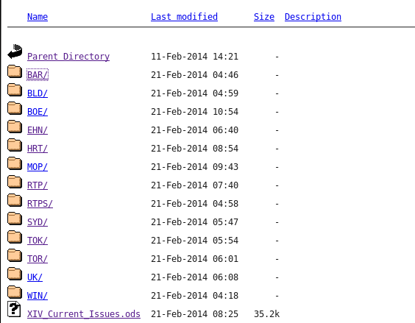

## Service Requests and PMRs

The following link could be used to open and read HW and SW PMRs:

<https://www-947.ibm.com/support/servicerequest/Home.action>

Before you could use it for SW PMRs , you should be registered by using IBM customer numbers.

Customer numbers for SCE+ can be found here:

[Notes://D01DBM20/8525784600685A0F/0A4E99592BC2F648802577C2003DF44B/44FB5A10A576F20485257C4300735539](notes://D01DBM20/8525784600685A0F/0A4E99592BC2F648802577C2003DF44B/44FB5A10A576F20485257C4300735539)

## Xray and EcuRep

If the support is asking for Xray you can use the following document:

[https://pokgsa.ibm.com/projects/s/sce-plus/XIV/Xray/Xray%20Collection%20and%20Upload.odt](https://pokgsa.ibm.com/projects/s/sce-plus/XIV/Xray/Xray Collection and Upload.odt)

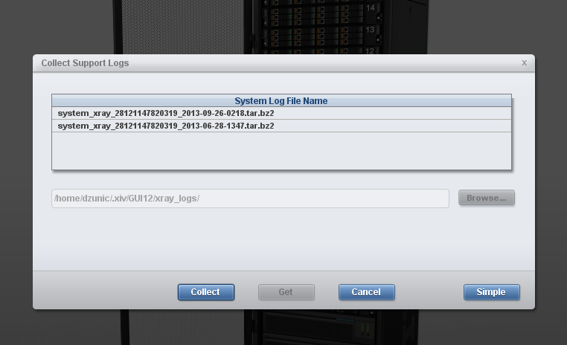

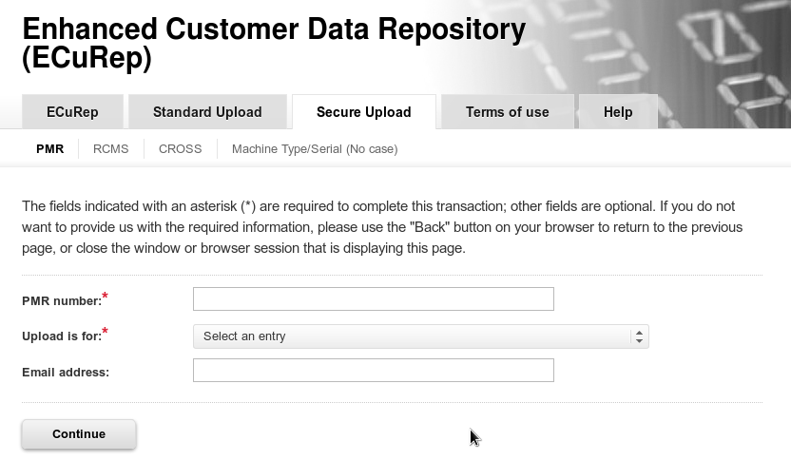

## XRSC

Support might ask you to enable XRSC or open VPN or open remote connection.

These are all different names for the support center and you can use the following document to do that:

[https://pokgsa.ibm.com/projects/s/sce-plus/XIV/Remote_Support_Proxy/Connecting%20and%20Disconnecting%20Support%20Center.odt](https://pokgsa.ibm.com/projects/s/sce-plus/XIV/Remote_Support_Proxy/Connecting and Disconnecting Support Center.odt)

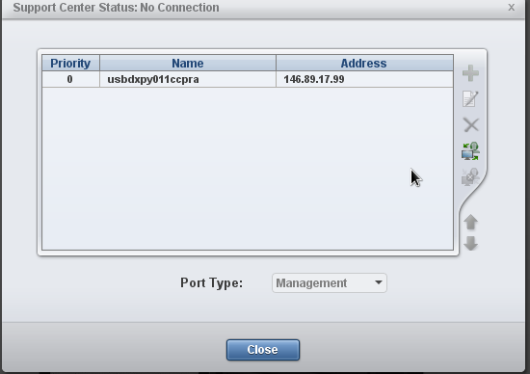

## Backup and Save Config Before HW/FW Change

The new Save Config script is now a part of the XIV scripts environment that is described in the following document:

[https://pokgsa.ibm.com/projects/s/sce-plus/XIV/Scripts/XIV%20Scripts%20for%20Linux.odt](https://pokgsa.ibm.com/projects/s/sce-plus/XIV/Scripts/XIV Scripts for Linux.odt)

[dzunic@oc6028821555 XIVscripts]$ pwd

**/home/dzunic/XIV/XIVscripts**

[dzunic@oc6028821555 XIVscripts]$ ll

total 56

-rwxrw-r--. 1 dzunic dzunic 7217 Feb 21 10:53 HealthCheck.ksh

drwxrwxr-x. 2 dzunic dzunic 4096 Feb 6 15:47 host_lists

drwxrwxr-x. 2 dzunic dzunic 4096 Feb 12 15:47 local_out

-rwxrw-r--. 1 dzunic dzunic 6201 Feb 12 15:12 **PreChangeBackup_1XIV.ksh**

-rwxrw-r--. 1 dzunic dzunic 5763 Feb 12 15:14 **PreChangeBackup.ksh**

-rwxrwxr--. 1 dzunic dzunic 3192 Feb 12 15:16 **SaveConfigs_1XIV.ksh**

-rwxrwxr--. 1 dzunic dzunic 2750 Feb 12 15:15 **SaveConfigs.ksh**

drwxrwxr-x. 4 dzunic dzunic 4096 Feb 7 15:08 TOOLS

-rwxrw-r--. 1 dzunic dzunic 2584 Feb 12 15:19 xcli_comm_1XIV.ksh

-rwxrw-r--. 1 dzunic dzunic 2197 Feb 12 15:19 xcli_comm.ksh

-rwxrw-r--. 1 dzunic dzunic 2441 Feb 20 11:46 xcli_start.ksh

## 90 days XIV Admin Password Change

Use the following document for the XIV admin password change:

[https://pokgsa.ibm.com/projects/s/sce-plus/XIV/Changing%20XIV%20admin%20password.odt](https://pokgsa.ibm.com/projects/s/sce-plus/XIV/Changing XIV admin password.odt)